**Aleks Itskovich (ai1221)**

**Julia/Haskell**

**Julia**

**Pairs With Target Sum**

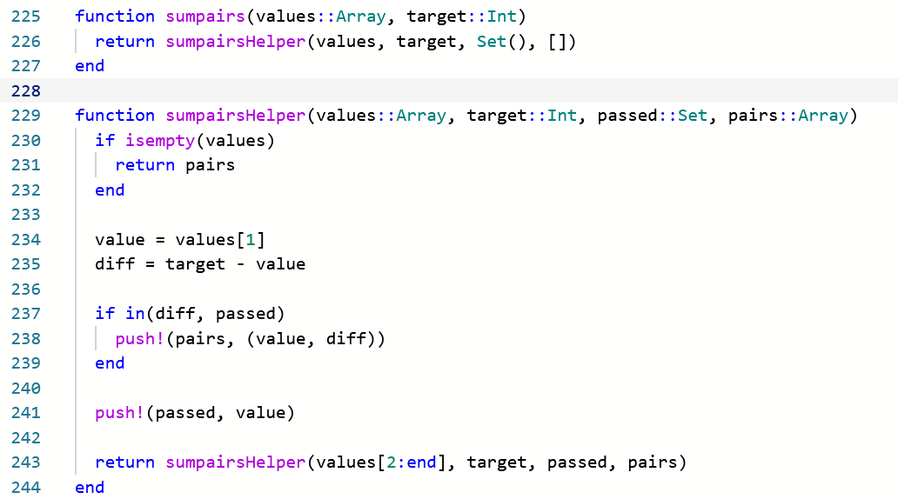

**Output**



**All Pairs**

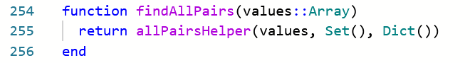

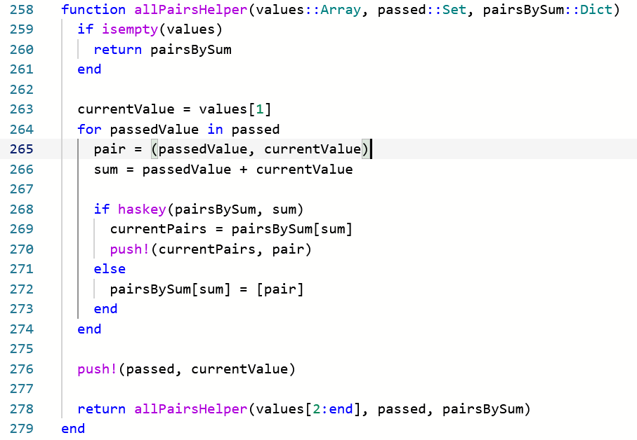

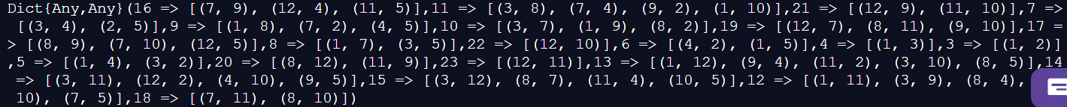

**Haskell**

**Pairs With Target Sum**

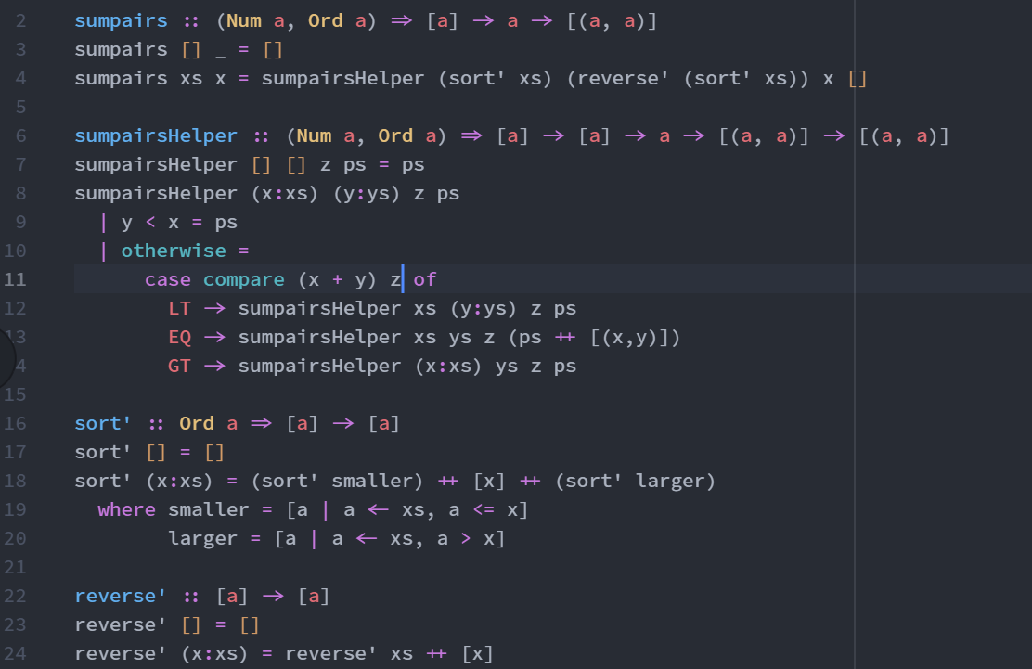

**Output:**

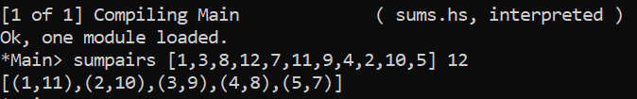

**All Pairs**

